

2016 Susan G. Komen Iowa Race for the Cure – Des Moines

**Team Captain Handbook**

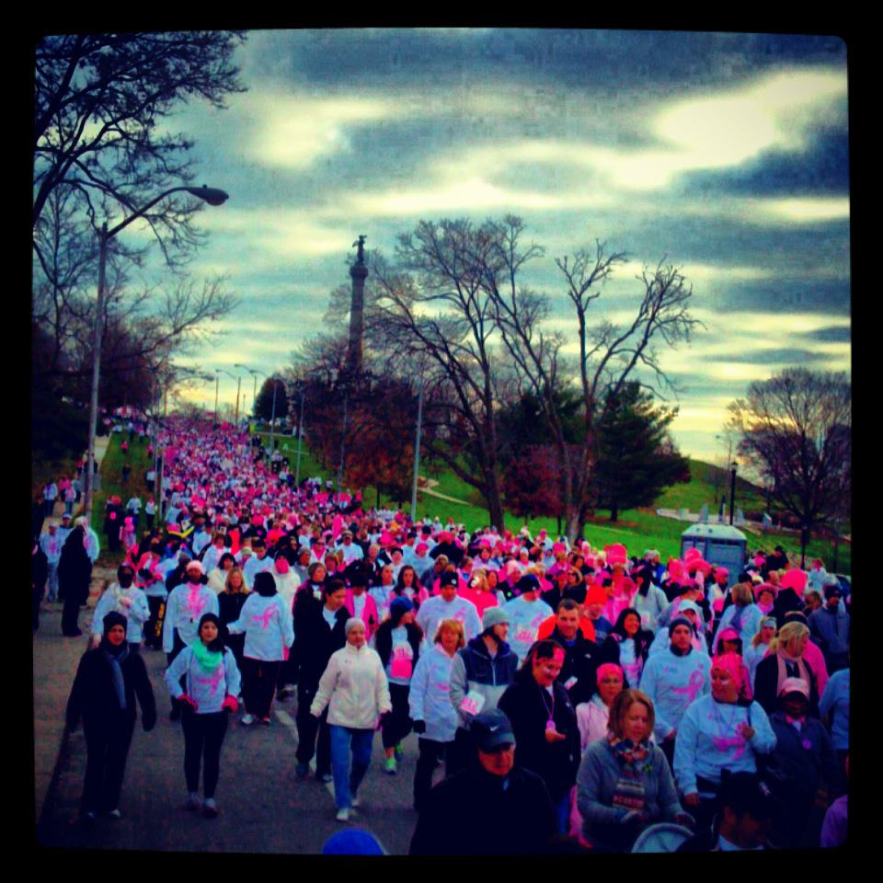

Getting Started: Starting and Joining a Team

**Starting a Team:**

1. Visit <http://www.komeniowa.org/registerDSM>
2. Click Start a Team
3. Enter your Team Name, company or organization (if applicable) Fundraising and Recruitment Goals. Then click next step and follow the Registration Steps

**Joining a Team:**

1. Visit [www.komeniowa.org/registerDSM](http://www.komeniowa.org/registerDSM)
2. Click ‘Join an Existing Team’
3. Enter the desired team name you would like to join, then click ’Search for Team’
4. Select the desired team name you wish to join from search results
5. Click ’Join Team’ and follow registration steps

Accessing your Team and Participant Center

**Team Center:**

1. Visit [www.komeniowa.org/registerDSM](http://www.komeniowa.org/registerDSM)
2. Click on the Race for the Cure Tab and then click on the ‘Participant Center’. You will be prompted to enter your login information. Enter your username and password.
3. Here you can get an overview of your progress, get fundraising tips, activities, import contacts from your personal address book, get team member report, view team roster, and connect with Facebook Fundraising purposes.

* Click on e-mail tab to send e-mails to current and potential team members
* Click on the progress tab to view your personal and team fundraising. Here you can personalize both yours and your teams fundraising page.

Team Basics:

**What is a Susan G. Komen Iowa Race for the Cure Team?**

It is an individual or a group of participants who join together to have fun, raise funds and awareness in the fight against Breast Cancer. Team members can come from your work, family, friends, or social networks.

**Tips for Building Your Team:**

* Customize your personal page to share stories, recruit teammates and fundraise
* Utilize your e-mail signature to provide readers with a link to your Personal Page
* Ask friends, family, co-workers and neighbors
* Publicize your team and the Race in newsletters, on your Facebook page and other Social Media Outlets.
* Utilize your Team and Participant Center and the prepared suggested messages
* Recruit team ambassadors to help spread the word
* Challenge your team members to sign up at least one other person

Team Captain Responsibilities:

Go to [www.komeniowa.org/registerDSM](http://www.komeniowa.org/registerDSM) and click “Form a Team”

**Recruit a Team:**

* Invite at least 10 or more people to join you. The more the merrier!
* Consider a Co-Captain(or two) to help you recruit and manager your team
* Communicate with your Team Members your Recruitment and Fundraising Goals
* Invite team and potential Team Members to register online by providing them all the information they need to register (“Join a Team” section above)
* Send regular reminders to team members about registering and offer to help in their fundraising efforts
* Make sure that your team members are aware of the registration deadlines and other important dates

Fundraising

**Basics:**

* Set a personal goal-Once you reach that goal don’t stop there; aim even higher!
* Compose your fundraising letter and/or e-mail-Start with one of the sample letters from our website or from your ‘Participant Center’

**How to Solicit Donations:**

* Online-Use the power of the Internet and Social Media to save time and effort
* Register online and set up a personal page
* Direct supporters to the website and click on” Support a Race Participant” to make a donation
* Add a link to your fundraising page (Email signature, Facebook profile, etc)
* Power of Ten Program, ask 10 of your friends for a $10.00 donation

**In Person:**

* Share your personal story or that of a friend/family member—share why YOU are involved with the event!
* Be the first person on your donor list
* Ask everyone you know-**People will donate, but you must ASK THEM!**

**Ensure Proper Individual and Team Credit for Fundraising:**

* Each participant must provide the correct team name when they register
  + All fundraising on their account will automatically be added to team total
* All funds must be submitted with the proper documentation
* Donations submitted in person or by mail must be accompanied by the offline fundraising form

**Pink Honor Roll Top Fundraiser Recognition:**

* The Top 100 Fundraisers each year become members of the Pink Honor Roll
* Each member of this exclusive club receives a commemorative T-shirt listing all the Top 100 Fundraisers
* On Race day you will enjoy a special breakfast and live music

For more information, visit the [Pink Honor Roll](http://komeniowa.org/pink-honor-roll/) page on the Komen Iowa website

Team Contests, Prizes & Incentives

**Team Challenge Awards:**

An award will be given to the largest team in each of the following team categories:

* Largest Survivor Team
* Largest Company Team (500+ Employees)
* Largest Company Team (Less than 500 employees)
* Largest Friends and Family Team

Team Challenge awards will be based on registered participants as of Tuesday, September 30th.

**Team Fundraising Awards:**

An award will be given to the largest FUNDRAISING Teams in the following categories:

* 10-25 Team Members
* 26-50 Team Members
* 51-101 Team Members
* 101+ Team Members

Team fundraising awards will be based on pledges received by Saturday, October 31st.

**Best Dressed Contest:**

Show off your team spirit and compete in our [Best Dressed Team Contest!](http://komeniowa.org/best-dressed-team-contest/)

For more information regarding rules, voting, and prizes available, click on the link above or visit the teams section on Komen Iowa website.

**Team Tailgating Contest:**

Our top 5 fundraising teams as of Friday, September 25th will receive their very own tent as a part of our [Team Tailgating Contest!](http://komeniowa.org/team-tailgating-contest/)

For more information regarding rules, deadlines, and amenities, click on the link above or visit the teams section on Komen Iowa website.

**High School Team Challenge:**

A participation based competition between area high schools to see who can form the largest team! The school that has the most participants will be declared the winner, and will receive special recognition on stage during the awards ceremony!

For more information, visit the official High School Team Challenge page. [Click here!](http://www.komeniowa.org/komen-race-for-the-cure/fundraise/high-school-team-challenge.html)

Important Dates to Remember:

|  |  |
| --- | --- |
| Tuesday, October 11th | Last Day to postmark paper entry and for packet mailing |
| Sunday, October 16th | Last Day to Register Online and to have packet mailed |
| Monday, October 17th | Prices stay the same but packets can no longer be mailed-must be picked up at Packet Pick Up days or on Race Day |
| Thursday, October 20th | Last day to postmark paper entry forms to be registered before race day. All non-online registrations must be done onsite at paper pick up or on Race Day at the Late Registration Tent |
| Tuesday, October 25th | Last day for team registrations to count towards Largest Team Awards |
| Wednesday, October 26th | Last day to register online (before 5 pm) all other registrations have to be onsite at packet pick-up or Race Day at Registration Tent |
| Wednesday, October 26th | Race registration prices increase $5 after 5 pm (timed runner-$44, Untimed 5K/1 Mile-$40,kids-$15) |
| Thursday, October 27th | Packet Pick Up at Merle Hay Mall 10am – 7pm |
| Friday, October 28th | Packet Pick Up at Merle Hay Mall 10am – 7 pm |
| Saturday, October 29th | Race Day-State of Iowa Capitol Grounds |
| Wednesday, November 30th | Last day for individual donations to be received and\or confirmed in order to count towards Team Fundraising Awards |

Frequently Asked Questions:

1. Do I need to pick up and distribute all my team member’s race packets?

No, those who register by Sunday, October 16th can choose to have their packet mailed to them. Additionally, individual team members may pick up their packets at packet pick-up or on Race Day.

2. If the team member misses the online registration deadline can they still register as part of the team?

Yes, however only the registrations received by Wednesday, October 26that 5 pm will be included in consideration for largest team awards. They must also pick up their Race packet during packet pick up day or on Race Day.

3. Where should I meet my team?

Pick a location familiar to everyone and designate that place as the meeting place. We also encourage carpooling.

4. Do we have a Kids Race?

Yes, The Kids Race will start at 10:15 am and is for children ages 2-10. The cost is $15.00 per child and they will receive a youth Komen Race for the Cure short sleeved shirt.

5. What are Registration Fees?

$30.00 Early Bird registration if registered by Tuesday, July 12th

$35.00 if registered by October 26th (option to have packet mailed prior to October 16th)

$40.00 when registering October 27th-29th

$15.00 for the Kids Race ages 2-10

$4.00 for Timing Chip (required for timed runners)

$4.00 for Packet Mailing

6. Do all Participants have to participant in the same event?

No, Team members can participant in the timed 5K, untimed 5K, the 1 mile walk and talk, or the Kids Race

Race Day Schedule

7:00 AM – Site opens to the public

7:00 AM - Survivor Tent opens for Survivor Breakfast, provided by Iowa Egg Council and Cookies BBQ

7:15 AM - Pink Honor Roll Breakfast for Top 100 Fundraisers from 2015 begins in the Pink Honor Roll Tent

7:15 AM – Stage activities and games begin

8:00 AM - Survivors gather at the Survivor Tent for the Survivor Parade

8:15 AM – Survivor Photo

8:30 AM –Aerobic Warm-up for Race on stage

9:00 AM – 5K Run (Timed and Untimed)/Walk begins

9:30 AM – 1 Mile Walk and Talk begins

9:45 AM – Last chance to start on the Race Course for any event

10:00 AM – Awards Ceremony and Top 25 Medal Winners announced from the stage

10:15 AM – Kids' Race (Age 10 and Under) begins on E. 12th Street behind the stage

10:30 AM – Kid's Race Winners announced from the stage

11:00 AM – Post-Race celebration begins (live music on stage)

12:30 PM – Site closes to the public

Contact Information

|  |  |
| --- | --- |
| General Race Inquiries | [info@komeniowa.org](mailto:info@komeniowa.org) |
| Information about Teams/Team Captain ?’s | Rhonda Baldwin (<rhonda.davis-baldwin@wellsfargo.com>) |
| Komen Iowa Affiliate, Phone | (515) 309-0095 |
| Komen Iowa Affiliate, Website | [www.komeniowa.org](http://www.komeniowa.org) |
| Komen Iowa Affiliate, Mailing Address | P.O. Box 8468, Des Moines, IA, 50301 |